Testing the Pinger

1. locahost (127.0.0.1)

1. cs.stonybrook.edu



1. 4 servers; each in a different continent
   1. Australia

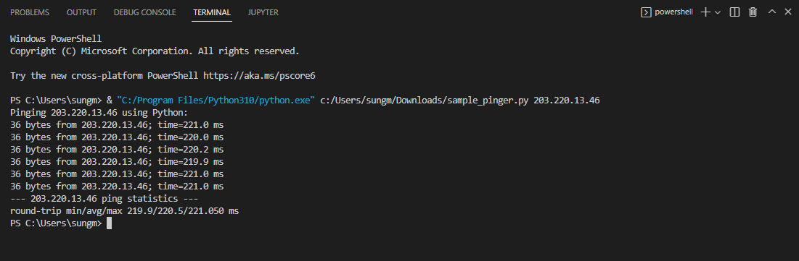

* 1. Korea

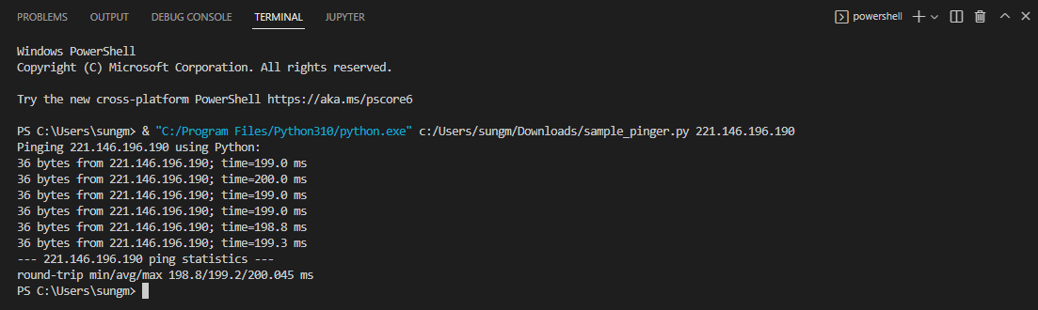

* 1. Brazil

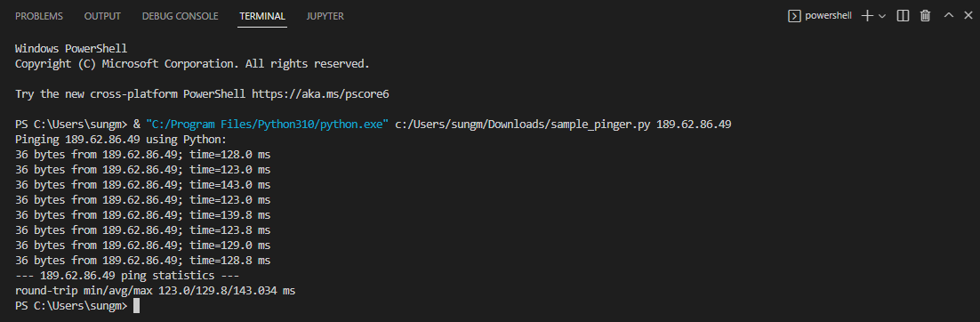

* 1. Zimbabwe

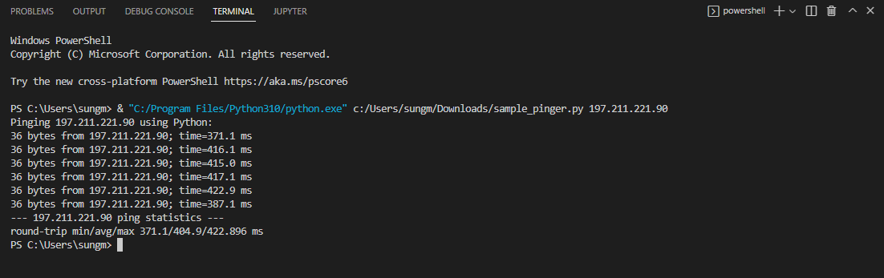

1. The ping to a server in Brazil had the fastest minimum round trip time. This is most likely due to the proximity of the server compared to the other three. The second fastest was the ping to a server in South Korea. South Korea is known for its powerful internet infrastructure. The third fastest was the ping to a server in Australia. It is geographically close to South Korea, attributing to its similar minimum round trip time. The slowest was the ping to a server in Zimbabwe, most likely due to difficulties in infrastructure despite being geographically closer than South Korea or Australia. The IP addresses for these servers were found using <https://public-dns.info/>.

To calculate the minimum round trip times, I extracted the timeWhenSent from the received packet and subtracted that from the timeRecieved variable that was initialized by the current time when said packet was received.